Apple in Kenya and Peru
Name
Institutional Affiliation

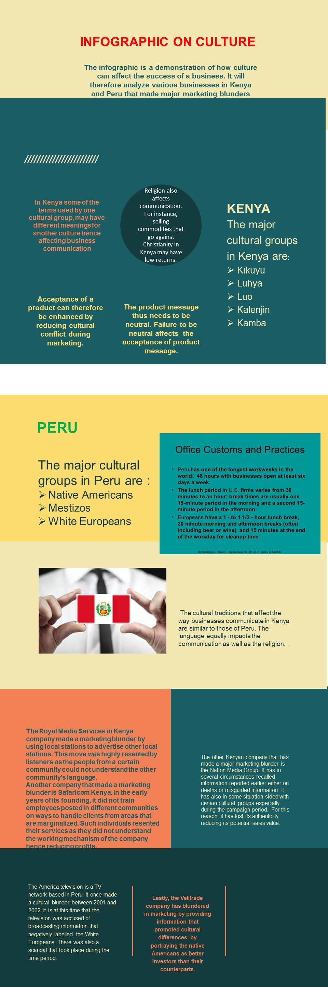

Apple in Kenya and Peru
The Apple business has been on the rise in Kenya and Peru over the years. More people have embraced Apple devices especially iPhones. It is mainly for prestige as they are perceived to be for people at a high social class. However, to ensure the business keeps thriving, it is crucial to ensure that it does not go against the culture of the named places (Nguyen, 2015). The essay is, therefore, a critical analysis of the Apple business in Kenya and Peru and ways to avoid cultural issues from curtailing the progress of the business.
The first way to prevent the problem of the language barrier is ensuring that the sales agents are ad versant with the two countries’ national languages. However, the devices should not be altered but should remain as they are to ensure there is cultural equality among all Apple product users. It, therefore, implies that the devices should not be impacting change on the lifestyles of the buyers. By doing so, there will be cultural independence. The use of a common language for all culture will also prevent resentment from Apple product from these regions as it was the case with the Royal Media Services.
It is also possible to prevent culture issues from arising in the Apple business by having local people as the marketers. This will ensure that there is understanding of both parties which will prevent misunderstandings. In addition, having local people as intermediaries increases the sales of the commodity as they can reach out to a larger audience. This ensures there is no tense interaction between the sellers and the clients of the commodities hence contributing to the growth of the business (Gudykunst & Kim, 2003). It will, therefore, prevent possible blunders in marketing.
The other way to prevent negative situations from occurring in the business is vetting any information before releasing it to the public. This will prevent misguided information which may make the clients lose their trust in the commodity. Furthermore, the Apple business in any of the two countries should not seem to target people from a certain social class. Such occurrences are likely to bring resentment from the clients as they feel they are not valued hence shifting to other providers.
The other way to prevent being a victim of cultural issues in business is choosing the right partners. Partners may be people who act as sales points and other interested groups. Having partners who embrace the success of the Apple business will ensure the success of the business. Such partners are likely to be resourceful in preventing the making of marketing decisions that will jeopardize the business (Gudykunst & Kim, 2003).
In conclusion, for the Apple business to be successful in Kenya and Peru, it is necessary to pull all the stakeholders together. After that, it is necessary to ensure that each one of them plays a crucial role in embracing the cultural diversity of the clients.

References
Gudykunst, W. B., & Kim, Y. Y. (2003). Communicating with Strangers: An Approach to Intercultural Communication. McGraw-Hill Humanities, Social Sciences & World Languages.
Nguyen, S. (2015). Organizational Culture, Leadership, and Success: cultural characteristics of thriving organizations.

